Assignment 1

Practiced code link of GitHub: <https://github.com/AliKabir1/appfirst1>

Output

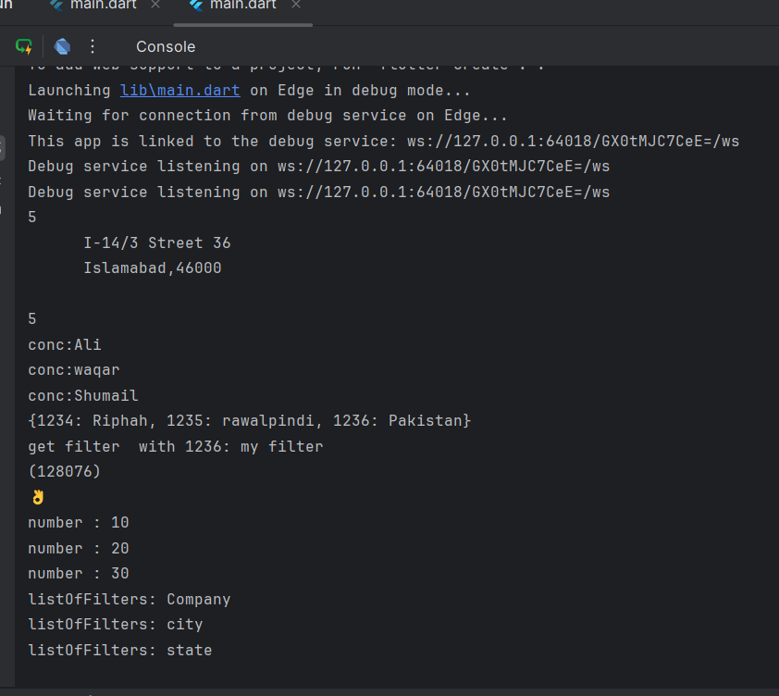

Changed code link: <https://github.com/AliKabir1/appone>

Output:

